Involve • Educate • Inspire
A Business and Cultural Exchange
ACB
Socially
Responsible
Leadership

Profile Information (Please TYPE this document)

Date Completed

Please complete the following, provide a bio, CV, copy of passport, a passport size photograph, , CV and 400-600 word letter of interest. The photo should be in a separate .jpg file. All documents must be submitted in one email to christinabruning@comcast.net; email subject AC GSW or WD Candidate First Name Last Name.

____(initial here) I understand participation is determined by a selection process. Upon selection and confirmation, I will be responsible for fully participating in scheduled programs, representing my country, and supporters respectfully and agree to purchase airfare in a timely fashion.

Delegate Information
Name (as it appears on passport)
Complete Post Address
Email
Skype
Home Phone
Cell Phone
Company
Website
Position and Responsibilities
Type of Business / Industry
Have you participated in a program supported by the Kazickas Family Foundation Program or the U.S. Department of State? Which program?
Are you vegetarian?

Background Information
Awards / Honors
Hobbies / Interests
Volunteer Activities
Why do you wish to participate in the delegation? Please share what you hope to “give” and “get” from the experience. Please explain how you will share your experience with others.
Feel free to include other thoughts you may have
Biography- See samples below

Sample Bio's

Rasa Ambrazeviciene is a Corporate Sales Manager for Air Baltic Corporation, a regional airline established in 1995 with offices in Latvia and Lithuania. Rasa is a member of "Save the Children Organization, "Think Tank Lithuania" a tourism group, and serves on the Board of Directors of the American Chamber of Commerce in Lithuania. She is keen on learning new things and improving her professional skills. Rasa hopes that her knowledge of human behavior, her life and work experience or just a word from her heart could help someone solve a problem or see it from another perspective. She enjoys reading, travelling, theatre, and the cinema.

Aida Zigmantaviciene is the Managing Director and a Member of Board of SATRIJA AB (www.satrija.lt). SATRIJA, established in 1955, is a famous Lithuanian high quality garment producer, both for: corporate wear, uniforms, Gore-Tex garments, protective clothing, and men’s and ladies’ formal and casual wear. SATRIJA employs 670 people and one the biggest Lithuanian employers leaded by a women-manager. The company exports 90% of the total production to the United Kingdom and Scandinavia. Aida is a Council Member of Kaunas Chamber of Commerce, Board Member of Lithuanian Apparel and Textile Association. She is also Student at Kaunas University of Technology, International Economics concentrating on the non-tariff barriers in international trade. Aida is married and the mother of two daughters. Aida’s hobbies include fashion, reading, traveling. Aida was a delegate of the 2002 Helsinki Women Business Leaders Summit, the 2004 Riga Women Business Leaders Summit and Across Cultures 2004.

Global Summit Info - Full participation in program sessions is compulsory

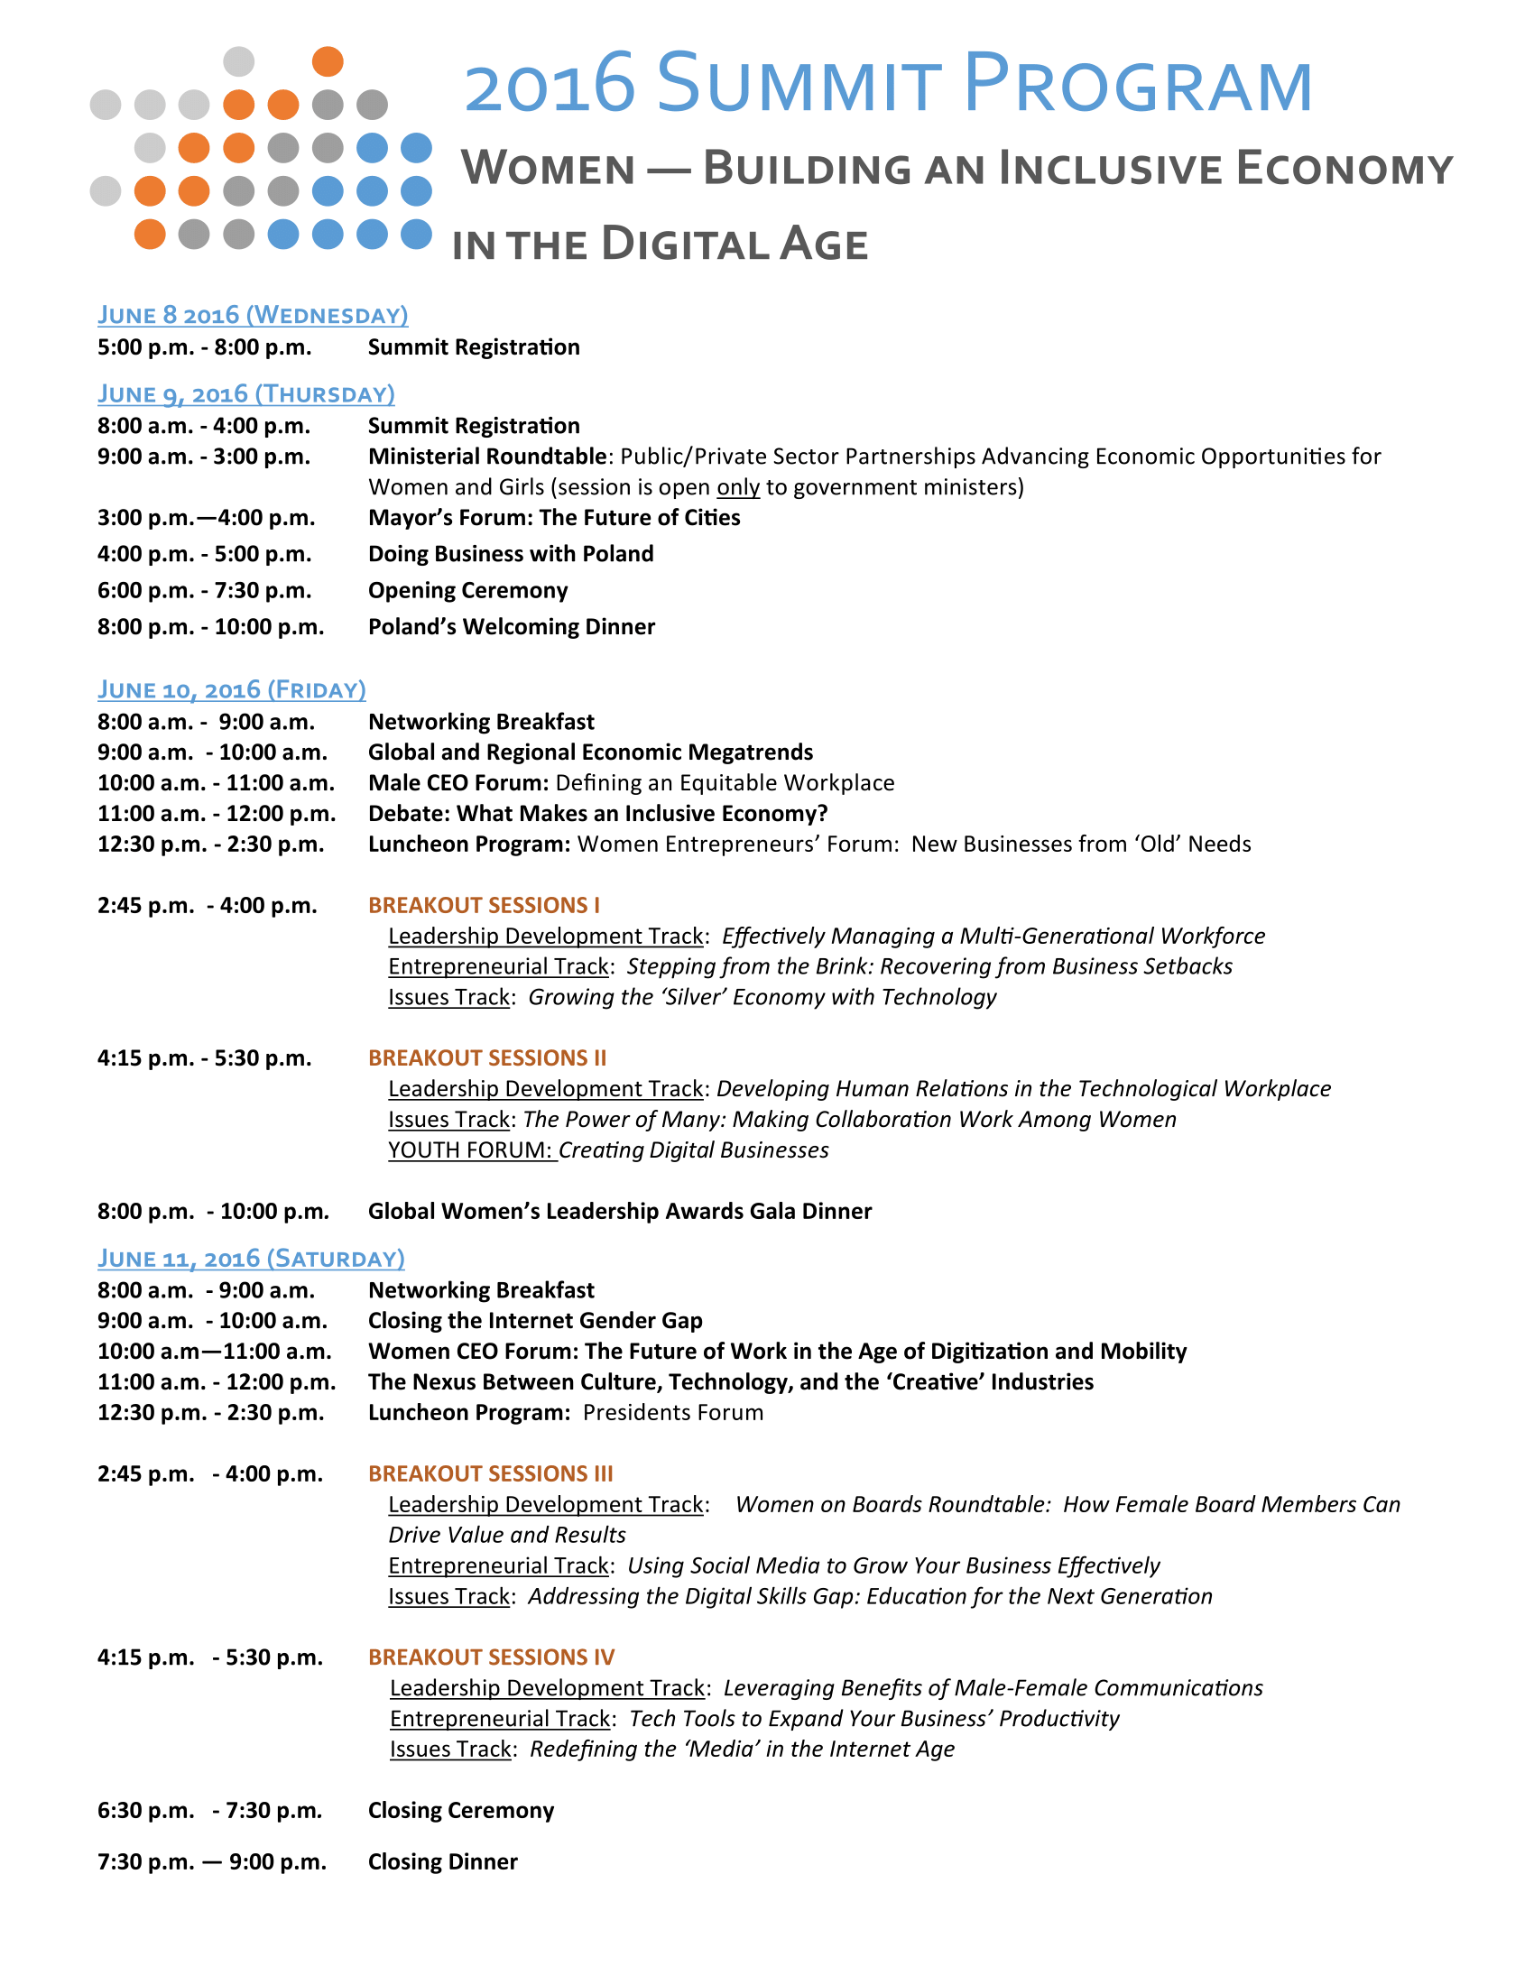

Global Summit Information - Identify sessions you will attend

June 10, 2016 (Thursday)
BREAKOUT SESSIONS
2:45 p.m. – 4:00 p.m. — BREAKOUT SESSIONS I  Leadership Development Track: Effectively Managing a Multi-Generational Workforce  Entrepreneurial Track: Stepping from the Brink: Recovering from Business Setbacks  Issues Track: Growing the 'Silver' Economy with Technology | List Track Preference
4:15 p.m. – 5:30 p.m. — BREAKOUT SESSIONS II  Leadership Development Track: Developing Human Relations in the Technological Workplace  Issues Track: The Power of Many: Making Collaboration Work Among Women  Youth Forum: Creating Digital Businesses | List Track Preference

June 11, 2016 (Friday)
BREAKOUT SESSIONS  2:45 p.m. – 4:00 p.m. BREAKOUT SESSIONS III  Leadership Development Track: Women on Boards Roundtable: How Female Members Can Drive Value and Results  Entrepreneurial Track: Using Social Media to Grow Your Business Effectively  Issues Track: Addressing the Digital Skills Gap: Education for the Next Generation | List Track Preference
4:15 p.m. – 5:30 p.m. — BREAKOUT SESSIONS IV  Leadership Development Track: Leveraging Benefits of Male-Female Communications  Entrepreneurial Track: Tech Tools to Expand Your Business' Productivity  Issues Track: Redefining the 'Media' in the Internet Age | List Track Preference

